Judge's Report - Term 1, 2024
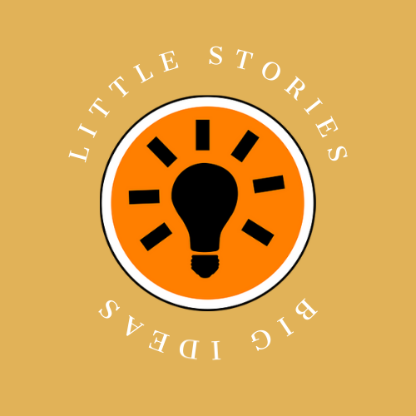
Theme: ADDICTION

Booyah! We kicked off 2024 with a literary bang, receiving a record-breaking 482 entries from across Australia! The energy and creativity in this term’s micro fiction comp was off the charts, with talented young writers from coast to coast showing us how it's done!

Thanks to all our Little Stories, Big Ideas teachers, parents, carers, sponsors, supporters, and of course, our amazing entrants! The electric buzz of a new school year is behind us now, and we've already taken the leap into Term 2 (how did that happen so fast‽) but let's take a moment to reflect on the remarkable stories that came from our Term 1, 2024 competition, where the theme was 'Addiction.'

As we reviewed the submissions, we were struck by the depth and honesty of the stories these young writers created. The theme of 'Addiction' inspired a wide range of interpretations, from stories that examined battles with substance abuse to those that explored technology, social media, and even addiction to success and achievement. Each entry offered a unique perspective, revealing the complexities and challenges that come with addiction, along with moments of hope, redemption and humour.

The following pages showcase our winners and runners-up in both the junior and senior categories, along with Honourable Mentions that stood out for their creativity and impact (and were oh-so-close to being winners!)

As we publish these stories on our social media platforms over the coming weeks, we hope you’ll join us in sharing them far and wide. These stories are a testament to the talent and sensitivity of Australia's next generation of writers, and we're excited to see what they’ll create next.

If you haven't done so yet, join us on social media to appreciate the impressive talent of these young writers.
Instagram: https://www.instagram.com/littlestoriesbigideascomp/
Facebook: https://www.facebook.com/littlestoriesbigideascomp

Entries are now open for Term 2 with the expansive theme of TOMORROW. We can't wait to see how students put their spin on this versatile theme! Enter here
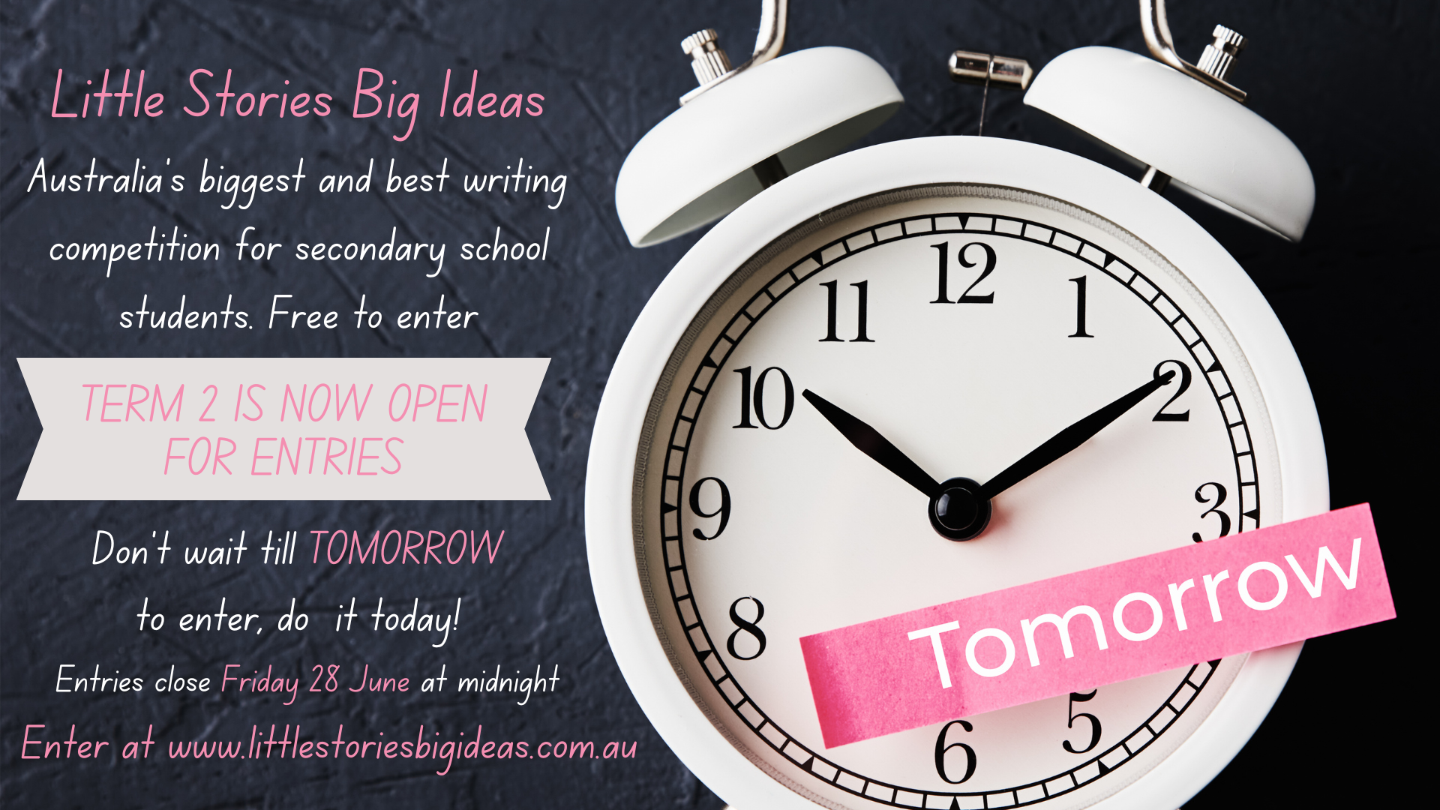

Please let anyone with a connection to a high school student know about Little Stories Big Ideas – students, parents, social circles, and anyone else you can bail up on the street corner or kinda awkwardly in the supermarket aisle. Encourage the kids to take their shot at winning great prizes and showcase their creativity. (You could say we’re ADDICTED to reading their work 😉!)

Thank you for your continued support, and here's cheers to TOMORROW!

Joe and Sarah

Year 10 - 12 Winners

First Place
Pantry by Emily Ford, Box Hill High School, VIC

The pantry is my home. The pantry is my solace. The pantry makes me feel better.
Cookie crumbs caress me under the covers.
A secret stash of empty packets under my pillow.
Fruit for school.
Junk for home.
“Where did the chocolate go?”
“I don’t know.”
My stomach refuses.
I keep eating.
There’s shame in my arteries and fat in my veins.
I keep eating.
My body begs me to be friends.
I beg each bite to make me feel better.
But there it is. An emptiness inside of me that food will never fill.
I take another bite.

Judge’s Comment: This exquisite entry captured our hearts and minds, as a deeply moving and poignant exploration of addiction. Emily uses powerful imagery to depict the inner turmoil and complex emotions tied to compulsive eating. The repetition and rhythm of the opening sentence creates a haunting resonance that stays with the reader long after the last line. The honesty and vulnerability make it a standout piece, highlighting the silent battles many face with food and self-worth. Emily beautifully encapsulates the emotional void that addiction can leave and compels the reader to empathise with the struggle.

Second Place

Miss Ocean by Charlotte Peacock, St Francis de Sales College, SA

I am addicted to your scent
Your saltwater burning my eyes
Your ripples of water under my toes
Your crash of waves against my body.
The sun sets your skin ashine,
Sending shimmers throughout your province,
Millions of lights, reflecting,
These lights, my purpose,
One.
I dive,
My red skin cools by your touch,
My flaky scalp sighs with relief,
I steady my breath careful not to waste precious air,
I watch your gown of lights,
As you dance in elegant movements,
Ebbing and flowing, in timeless rhythm,
Glistening by the sun's gentle kiss,
Miss Ocean,
You are my addiction.

Judge’s Comment: Charlotte’s writing gracefully captures the allure of the ocean, presenting it as an irresistible force. Through vivid imagery and evocative language, Charlotte creates a sense of immersion that allows the reader to imagine the setting sun, feel the coolness of the ocean's touch, and the soothing rhythm of the waves. The naming of this special place as "Miss Ocean" is a brilliant poetic personification, and the combination of sensory detail and emotional depth illustrates the profound connection between humans and nature. A beautifully written ode to the sea that resonates with readers who share the same addiction.

Third Place
Empty Flicks by Darcy Lynn, Wahroonga Adventist School, NSW

My thumb flicks lazily up and down the screen and I watch, mindlessly, each new blip of content.
I feel like I am in two different places. I am replicating the coolest trends with famous influencers. I am languidly stretched across my bed. I am the epitome of oxymoron – entertained boredom.
But each new flick allows me to explore another moment in another life, in another place, with another person – and I am flooded with dopamine.
I put down my phone. But my thumb continues to trace the phantom of my phone. I will succumb again.

Judge’s Comment: Darcy’s piece, "Empty Flicks”, keenly captures the hypnotic draw of technology and the addictive pull of social media. The narrative reflects the paradox of feeling connected while simultaneously being disconnected. The vivid imagery of the thumb flicking on a screen, even after the phone is put down, resonates with many who find themselves caught in the endless cycle of scrolling, which in hindsight often feels mindless. The precise use of language cleverly conveys the simultaneous rush of dopamine and the emptiness that follows. This entry is a powerful commentary on modern technology's impact on our lives, inviting the reader to reflect on their relationship with the digital world.

Honourable Mentions:
- Scarred Souls by Anonymous, Flinders Christian Community College, VIC
- Siren by Eva Gately, St Pauls Catholic Secondary College Kempsey, NSW
- Illuminating Realisation by Jason Ly, Glenala State High School, QLD
- Clandestine Tendrils of Toxic Dreams by Anonymous, Mount Eliza Secondary College, VIC
- Introduction by Trang Nguyen, Buckley Park College, VIC
- Look Up by Anonymous, Toorak College, VIC
- Help Us by Elise Nikkinen, Cape Byron Rudolf Steiner School, NSW

Year 7 – 9 Winners

First Place

Likes and Lies by Emily Dukeson, Kawana Waters State College, QLD

Pose.
Click.
Adjust.
Click.
Suck in stomach.
Click.
The lighting isn't great on that one.
Delete.
Reapply lipstick. Adjust ponytail.
Click.
Ah, that's the one.
Pretty, but effortless.
Seemingly candid.
What all photos must be.
Filter: applied.
Pimple: erased.
Perfect.
Photo: Uploading…
Caption: Sunshiney Day :)
Hashtags: #candid #nofilter #beyourtrueself
It took an hour, but that doesn’t matter.
Fingers tap nervously in the wait for the verdict.
Then…
Allie028: Omg stunning <3
4 likes
Sophhhieee: That summer sun!
27 likes
More comments
A soft smile, gracing the lips
Addicted to the validation?
Willing to do anything for it?
Surely not.

Judge’s Comment: A relatable anecdote told in real-time, with a clever ‘peek behind the curtains’ at the end, as the reader gains access to the narrator’s inner thoughts in the final line. A lovely open ending that gives the reader something to ponder.

Second Place

The (Generic Phone Brand) 16 by Victoria Golz, The Mac.Robertson’s Girls’ High School, VIC

bRRing! bRRing! bRRring!
Bzz. Bzz.
Ding!
It’s a modern orchestra, climaxing into an ear-splitting cacophony enough to overwhelm the listener.
It is a master of engagement, having honed its method over the years.
Chime!
RI-N-G, RI-N-G
Most importantly, it's a paradigm of subtly.
Subtle in the way it has secured its claws into the hivemind of society.
It is worse than any drug. More potent, more effective.
A sheep in wolf’s clothing.
A poison advertised as a commodity.
An addiction wrapped up in a portable, hand-held rectangle-
BUzz! BUzz! BUzz!
Sorry – I’ll get back to you later.

Judge’s Comment: The cleverly titled “The (Generic Phone Brand) 16" is an insightful exploration of our relationship with technology. Through the use of onomatopoeia (when words sound like the noise being described) and rhythmic pacing, Victoria’s piece creates a sensory experience that draws the reader into the chaotic symphony of modern life. Her metaphors and analogies, such as the "sheep in wolf's clothing," emphasise the deceptive allure of technology. Her writing captures the spirit of the competition's theme while delivering a memorable message that will no doubt resonate with readers of all ages. A thought-provoking commentary on the impact of constant connectivity.

Third Place

Fat Cat by Anonymous, Bunbury Catholic College, WA
“She’s overweight! That’s unhealthy!”, they all say. Everyone who came to my house commented on my physique. I may have a slight addiction to cat treats, and a small hatred for, you know, moving. But I see you humans with your Facebook, your TikTok. I see you with chocolate, your alcohol. That’s right, I know things. So, don’t look down on me and my ways. The other day, I smacked my human’s phone off the counter so she would pay attention to me instead of the phone. It was for her own good! And everyone says dogs are the loyal ones.

Judge’s Comment: "Fat Cat" offers a humorous yet thought-provoking perspective on addiction through the eyes of a cat. The playful narrative draws parallels between human and feline habits, highlighting our own addictions while poking fun at the cat's indulgence. The use of conversational language and lighthearted tone makes this piece engaging and relatable. The twist in perspective, where the cat acknowledges its own addiction but also points out human shortcomings, adds depth and wit to the piece. The story reminds us not to judge others too harshly when we all have our quirks. A delightful, original take on the theme.

Honourable Mentions:

- Words by Autumn Winchester, Cape Byron Ruldolph Steiner School, NSW
- Muted Compliments by Helen Li, Fort St High School, NSW
- Digital Refuge by Nico Palstra, Balwyn High School, VIC
- Digital Echoes by Amber Brar, Illawarra Christian School, NSW
- A Sick Love by Ana Ruiz Davila, Mary Mackillop Catholic College Wakely, NSW
- Digital Dusk by Kaavya Gupta, Abbotsleigh, NSW

