Judge's Report - Term 3, 2023
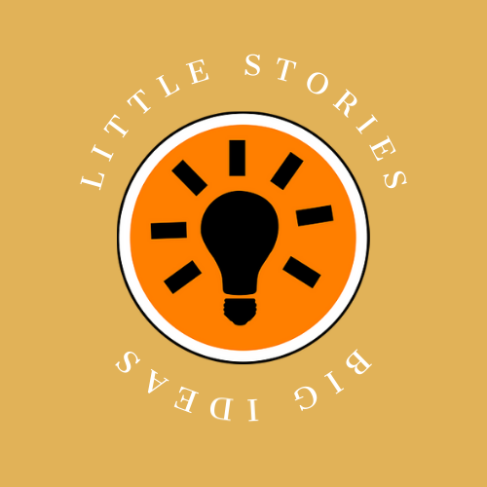
Theme: VOICE

When we launched Little Stories, Big Ideas almost three years ago, our founding vision was to provide a platform for Australia’s young writers to raise their literary voices. We strive to use topical and relevant themes that reflect the world and times today’s youth move through, so, with our ethos and a Referendum on the nation’s doorstep, we decided VOICE was a fitting choice for Term 3’s competition. Our entrants must have thought so too...Term 3’s competition generated 400 entries from writers in every state and territory!

Many submissions for ‘voice’ were humanitarian in nature: powerful, persuasive, passionate and perceptive pieces that explored what it means to be voiceless through marginalisation, persecution, gender or cultural oppression and othering.

Some stories looked inward, examining fears, phobias, confidence and character with insight and introspection. Ohers took a fictional approach, celebrating the art of storytelling with micro pieces steeped in fantasy, sci fi and horror that showcased their creative approach to the theme.

As always, we were moved and impressed with the quality of writing, the imagination and creativity to explore challenging concepts in interesting and bold ways, playing with narrative techniques and structure, and the self-awareness and empathy that shone through to make micro stories mighty!

As well as our winners and placegetters, we have our usual contingent of Honourable Mentions. Judging is never an easy task, and we trust that entrants will continue to be encouraged and inspired to share their words and ideas.

We hope you’ll take the time to read and celebrate them all as we post them our winners and honourable mentions on our social media platforms over the coming term. If you haven’t already, why not give us a follow and enjoy the teen talent:
- Instagram: https://www.instagram.com/littlestoriesbigideascomp/
- Facebook: https://www.facebook.com/littlestoriesbigideascomp

The theme for Term 4 MAGIC has now opened for entries. We’re looking forward to the various ways students will interpret this multifaceted theme!
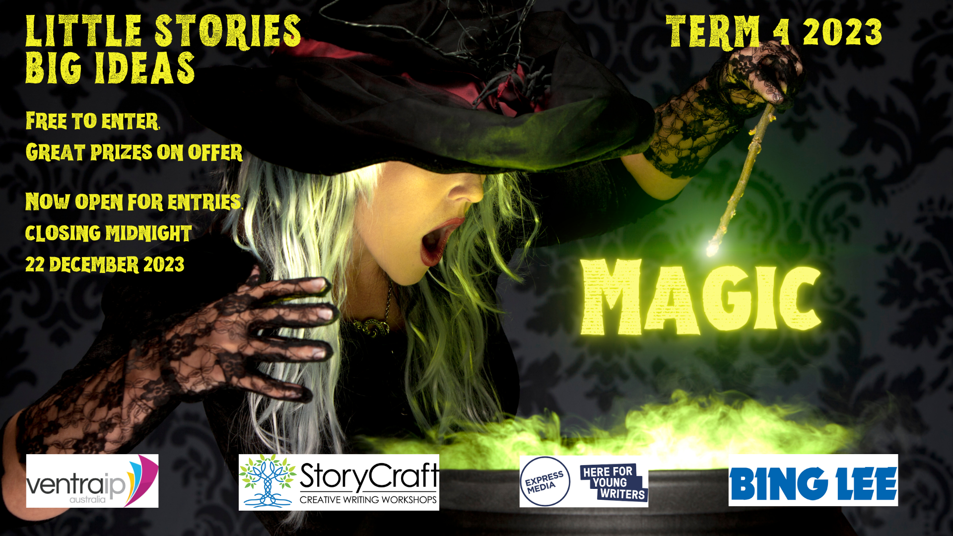

Please spread the word to your students, membership base, children, social networks, and anyone you think would be interested in submitting their work for the chance to win terrific prizes while flexing their creative muscle. We’d love to read their entries!

Thanks as always for your ongoing support, and all the very best for Term 4 and beyond.

Joe and Rebecca

Year 10 - 12 Winners

First Place
To Dance on Air in the Heart of Cuba by Amelia Tu, Shalom College, QLD

as aretha said a little prayer
in a tinny, scratching voice,
we’d move the table
to make a dance floor.
i remember
you sold that table.
i loved when you did; we got a permanent dance floor.
that was back when i couldn’t spell
‘dispossession’.
but even though
poverty was our neighbour,
sitting cross-legged on the floor,
staring at stars on our night sky ceiling,
we told each other it’d be okay because
at least
we had each other
and a permanent dance floor.
we stopped praying with aretha
as the record ended; eventually,
you had to sell that too.

Judge’s Comment: Amelia Tu is a prolific and talented writer, submitting multiple entries each to Little Stories big ideas each term. In this piece, Amelia captures the essence of poverty using a moving and emotionally-weighted snapshot in time. The narrator’s voice conveys optimism - the constitution to make the best of an unsatisfactory situation - yet the final stanza cements our understanding that for the “we” in this story, a happy ending is unlikely.

Second Place
Boy’s Club by Kierah Hayward, Homeschooled

Gently, carefully I peel off my lips.
And throw them carelessly into my schoolbag.
I grip my tongue between my forefinger and thumb,
And tug,
Until it lays flat in my palm,
Curled and wet,
and unmoving.
Maths is a boys’ class.
I have no voice between these four walls.
When the teacher calls out the questions,
I know all of the answers,
Sometimes,
Before any of the boys do.
Where textiles and food-tech,
Fill others’ thoughts,
Mine swim with numbers.
But Math’s is a boys’ class,
And it belongs to them.
Between these four walls,
So does my voice.

Judge’s Comment: While the days of gender-divided school subjects are thankfully a thing of the past, some stereotypical crumbs still get scattered. The idea that boys were better at maths and science / girls were better at more domestic-centred or “gentler” subjects was very much an ideology of its time. We like the way Keirah has explored this outdated concept with her well-structured and paced poem that elicits immediate attention with its emotive opening lines.

Third Place
Rope by Nigella Gillard, Kolbe Catholic College, WA

From every angle
each voice, a rope,
its string of sounds,
echoes differently.
Some ends are frayed,
rough like calluses; cracked skin on soft lips,
thin from loyal wear.
Others are tied neatly.
Fibrous chains
dipped in wax, held
steady with purpose.
Sentences twist in
a helix. Fact, fiction; artfully woven into
bureaucratic promises.
Is one rope better than
the others? Does the
wisdom of the worn
outdo their fragility?
Now both ends lay
in my grasp, and only I
choose the voice
which bears my weight.

Judge’s Comment: The comparison of voice to rope works beautifully in this marvellous metaphoric offering that examines the power and vulnerability different voices can wield… or yield.

Honourable Mentions:
- Our Way Forward by Zara Lawrence, All Hallows’ School, QLD
- Dear Sapling by Mia James, Mount St Benedict College, NSW
- You by Olivia Luu, Cerdon College, NSW
- Noise by Jeremy Rusli, Mansfield State High School, QLD
- The Colour of Violence by Anonymous, Alia College, VIC
- The Inbetween by Anonymous, St Bede’s College, VIC
- Revolution by Emily Brown, Home Education Unit, QLD
- Breaking Anxiety’s Silence by Grace Boutros, St Charbel’s College, NSW
- A Coward’s Move by Lily Turbill, Albany Senior High School, WA
- Voice by Pen by Doris Wei, Mansfield State High School, QLD
- The Melodramatic Poet by Veronica Keelan-Slight, Mackillop College, NSW

Year 7 – 9 Winners

First Place

, etc. by Adrita Saha, James Ruse Agricultural School, NSW

ditsy floral sheets spread evenly, not a crease
in the past that seems to be
folded nicely like washing, smelling like lavender
and roses and powder, dizzyingly
sweet, like Dior perfume samples tucked away
for the better days.
it’s funny, but why would I remember you?
you, without a voice to show that you are there
a constant as always, silent, but there
leaving an imprint on me deeper than
a thousand different words in
a thousand different languages.
and yet I remember the ditsy floral sheets
and now they seem like something of an
entirely different timeline.

Judge’s Comment: Adrita’s moving ode left a lasting resonance we couldn’t ignore. It’s beautifully nostalgic expression of past meshing with present through the “everyday” is emotionally rich. There must be something in the water at James Ruse Agricultural School – the quality of entries put forward each term is super impressive!

Second Place

A Lime-green Jacket and a Second Chance by Dulara Jayasekara, Mount Waverley Secondary School, VIC

The resemblance is striking.
My mother, a young rebel captured only upon a dog-eared photo album, donning the lime green leather jacket I wear now.
Form-fitting, it molds to my shoulders almost instantly, a phantom of the freedom fighter that I never got to know. The slight whisper and creak of leather worm their way into my brain, reminders - and warnings - to not be so reckless.
Don’t speak up, they say.
Keep your head down.
Don’t make eye contact.
Be nothing.
No-one.
But I wore this jacket for a reason-
Because this is my Voice…
And it's my second chance.

Judge’s Comment: We love the power and the passion this piece inspires. The intergenerational dynamics in this story, and the representation of the titular object, left us wanting to know more about the mother’s past, and the daughter’s future.

Third Place

I Was Once a Teen Girl Too by Shenaya Sinah, Tara Anglican School for Girls, NSW

“I was once a teen girl too,” Mum says.
Bell rings for home
How can I go home when school follows me on my phone?
Snapchat the trending habitat.
Hours on end, argue and backchat.
Staring at myself in the mirror
No hourglass makes me quiver.
My weight, the biggest crime
Drop alotta kilos, it takes no time.
I take out the pen.
My only escape that puts me into zen.
My problems still knocking on my door.
Relying on the watermelon fumes, even though I said I wouldn’t, I swore.
“I was once a teen girl too,” Mum says.

Judge’s Comment: This piece gave us All. The. Feels. An all too familiar snapshot of contemporary teenage life is bookended by the mother’s well meaning, yet out of touch, refrain. That teen girls (and boys) have always faced pressures is undisputed, however the challenges for today’s teens are (not less) but different to that of their parents’ time. Shenaya’s piece will be highly relatable to many.

Honourable Mentions:

- Echoes of Unity by Jack Blaney, Brisbane State High School, QLD
- Forest Song by Karunamuni Sanuli Karunaratne, Marist Regional College, TAS
- Sincerely, the Voice in Your Head by Charlotte Brown, Ravenswood School for Girls, NSW
- Voices by Dev Raval, Churchie School, QLD
- Straitjacket by Hannah Yu, Abbotsleigh School, NSW
- Silent or BOLD. You pick by Anwesha Poddar, Baulkham Hills High School, NSW
- Blacked Out Praise by Annabelle Djaja, Hornsby Girls’ High School, NSW
- Dystopia by Isabella Chalker, Bunbury Senior High School, WA
- The Voice of Music by Indigo Leyland, St Mary’s Catholic College. QLD
- The Sad Voice of Society by Chloe Tabet, Tara Anglican School for Girls, NSW
- Red Thread by Mythri Sarker, Hurlstone Agricultural School, NSW

MORNINGTON PENINSULA LOCAL WRITERS’ AWARD

The Starling and the Fairywren by Jocia Power, Mount Eliza Secondary College

To my Starling,
You know I’ve never liked doing what I was told. But for you, I tried, so hard. They wouldn’t listen. I screamed and cried, but nobody cared.

Remember when we would lay beneath the tree in your backyard? Your laughter sounded how it feels to be in the sun. Warm, soft. You, my girl, are the only one I’ll miss. I’ll miss whispering about secrets of our universe with you. I’ll miss hearing your heart beat while laying on your chest.

I won’t say goodbye. So, I’ll meet you in the stars, ok?
Love,
Your Fairywren

