Judge's Report - Term 4, 2022
Theme: Fear

Term 4’s competition with the theme “FEAR” closed our second year of Little Stories, Big Ideas and, as has been the trend with each passing term, drew a record number of entries. 431 secondary school students country-wide penned entries for Term 4…that’s roughly 400 more than our very first competition in Term 1 of 2021! We’re so proud of this growth. It means our reach is increasing, and more of Australia’s young writers are discovering a platform to showcase their writing, which was our founding vision from the start.

As we roll into 2023, and another year of competition, we would like to extend our gratitude to all who have helped shape Little Stories, Big Ideas. Our special thanks to our generous sponsors for enabling us to continue to provide terrific prizes for our winners. Our gratitude to all the educators who have shared our competition with their students with such enthusiasm and supported them in their creative writing. Our admiration and respect to all the students who have entrusted us with their precious words. Without all of you, we wouldn’t have this competition at all!

As we move into the winners and placegetters for Term 4, you might notice some are written by “Anonymous” authors. After discussion, from Term 3 we have allowed entrants to remain anonymous if they wish. Little Stories, Big Ideas means just that: micro fiction surrounding issues that matter, in whichever way the author chooses to interpret them. The themes we choose are deliberate in their weightiness. While we understand that ‘no author is their writing’, we also acknowledge that—especially for young and emotionally-developing writers—feelings of being ‘exposed’ or fear of judgement or retribution (perceived or otherwise) can be very real. Especially when writing through a lens of culture, gender, race, religion, disability, or sexuality. We want to ensure every writer feels comfortable in submitting their work, and we want to cast our net of opportunity and inclusion as wide as possible.

Alrighties, then! On with the results!

The theme of ‘FEAR’ drew an eclectic mix of entries across a diversity of styles. We enjoyed reading stories inspired by the very real horrors that blight contemporary life, to terrors dredged from dark wells of imagination. Some entrants drew on phobias and folklore, while others explored everything from ectoplasm to existentialism. Others infused their work with a welcome hint of humour, or a bold brush of bizzarro.

Judging is never an easy task. Please join us in congratulating the following authors whose words left a lingering resonance we couldn’t ignore.

The theme for Term 1 LOVE has now opened for entries. Please spread the word to your students, membership base, children, social networks, and anyone you think would be interested in submitting their work for the chance to win terrific prizes while flexing their creative muscle. We’d love to read their entries!
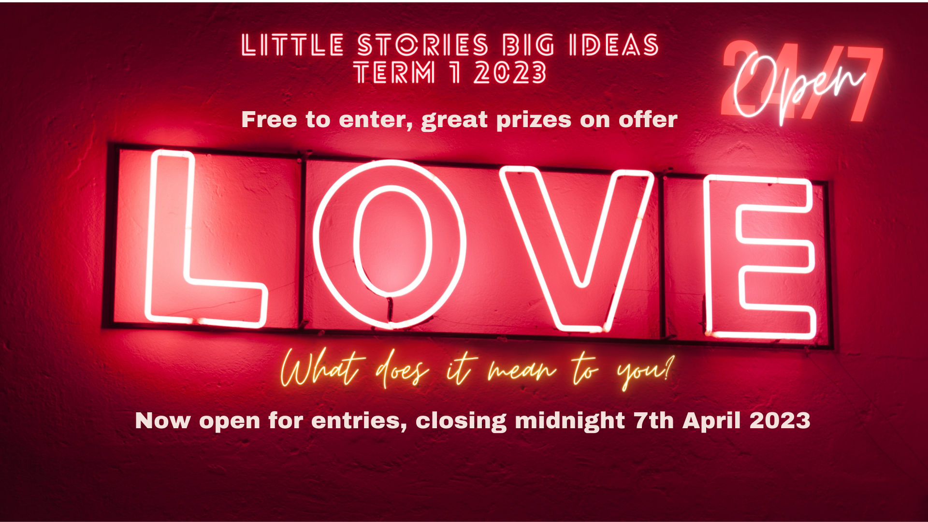

Thanks for your ongoing support, and all the very best for the 2023 school year.

Joe and Rebecca

Year 10 - 12 Winners

First Place
Ten Minus Two (Tu) by Amelia Tu, Shalom College, QLD

Eight eyes.
Eight legs.
A sinister web.
Wisps of memories still hang from the walls of a house built on despair.
Though the sun still rises each morning, the darkness constantly enveloping the scene is stifling.
Eight eyes stare from within, cursed with a futile longing for connection.
Eight legs traipse across dusty floorboards that creak, flexing in search of any semblance of love.
Holes in the walls echo with fear; The home is no longer a sanctuary.
Only eight eyes and eight legs bound as one body,
One entity.
Eight eyes.
Eight legs.
Four people.
My family.

Second Place
For Fear of a Writer by Zara Perry, Ravenswood School for Girls, NSW

Lost souls wander
On and on through worlds of our own making.
Veritable wraiths in this universe of light and shade.
Ever effervescent, so rarely still, our minds.
Heralding calls of solitary pain or joy
Are caught high in the clouds, invisible.
The world turns away from the rage that
Escapes onto bare pages; dead trees aren't scary like living, speaking faces.
Ambiguous answers avoid our attention
Long into the night, after hours of silence,
Only the wind hears the sighs of the lonely.
Numbing, biting breezes of feeling, rattling our bones.
Enveloped in darkness, inspiration seekers, we wait, alone.

Third Place
Under the Tree by Zoe Copeland, St Joseph’s Regional College, NSW

Under the tree,
I met you
Fresh faced and boyish,
Your eyes a grandeur blue,
Under the tree,
You danced,
Laughing,
Tender and moon-eyed,
Under the tree,
You proclaimed
Love undying,
Eyes questioning,
Under the tree,
I replied,
For I loved you too,
eyes dazed,
Under the tree,
You receded,
Becoming a husk,
Your eyes vacant,
Under the tree,
You cried,
Tides of sorrow drowning you,
Leaving you glassy-eyed,
Under the tree,
You vented,
As I tried to comfort,
But your eyes reflected its futility,
Under the tree,
I find you,
Hanging,
Closed eyes, lips blue,
Just as I feared.

Honourable Mention:
- I Fear by Carmel Bai, Ravenswood School for Girls, NSW
- The Fear by Abigail Barfield, Pymble Ladies college, NSW
- Tsunami’s Dance by Shreya Dutta, Hornsby Girls High School, NSW
- The Moment Before by Emily Brown, Home Education Unit, QLD
- Bundle of Cries by Aiesha Kilgannon, Willunga High School, SA
- Sleepless Night by Alphonsa Benjamin, The MacRoberston Girls High, VIC
- The Classroom by Alanna Lu, Trinity Catholic college, NSW
- Anxiety by Hana Wong, Modbury High School, SA
- The Trapped by James Hillier, Newtown High School of the Performing Arts, NSW
- My Birthday Present by ANONYMOUS, Hornsby Girls High School, NSW
Year 7 – 9 Winners

First Place
Slipped by Noa Gomberg
Sore throats had never meant infections
rather
Bitter tea with
Ever faint hints of honey.
Masks were reserved for high-risk surgeries
and
Patients walking toward a dim light.
Hugs were once reserved for polite greetings
How did they become such
heart-wrenching goodbyes?
Perhaps we walked this thin tight rope called
Fear
and
Slipped
before reaching the end?
Perhaps we all became patients
trudging towards the flickering light?
Perhaps
We all became the doctors
And nurses
And teachers
And kinders
Precariously gluing together the pieces of our old lives
In childlike hopes
That one day we’ll find the
“New Normal”?

Second Place
Fight, Flight or Fright by Alna George, Yeronga State High School, QLD

Congratulations!
New character unlocked!
Abaddon!
would you like to equip Abaddon???
yes no
you have selected... yes!
would you like to continue onto level 666???
yes no
you have selected... yes!
...
(WARNING: level 666 is not for the fainthearted!)
are you sure you would like to continue???
yes no
...
you have not selected.
select in 10 seconds.
or else.
10.
9.
8.
7.
6.
5.
4.
3.
2.
1.
Oops! looks like time ran out!
Sorry! I’m afraid you'll have to go through a punishment!
Turn around.
Now.
Third Place
Memories Mourned by Sarah Morrow, Albany Senior High School, WA

When my thoughts became garments
Everything seemed to change
They weighed me down, bound my arms
Fusing to my bones like mange
I’ll never forget the black-cloaked man
The one that stitched the fabric
His face burned in my mind
His words pained and static
“when would it end?” he asked
I tend to ask the same
So I took his cloak in favour
And he left me with his name
“Gone and still forgotten”
My thoughts began to weave
And as I took the title of fear
My past would always grieve.

Honourable Mentions:

- Ink by Harry Tong of Knox Grammar School, VIC
- In the Spotlight by Amy Parker, Gosford High School, NSW
- Walking on Eggshells by Charlotte Davis, St Patrick’s College, NSW
- The Fear of Failing by Lily Grant, St Mary’s College, NSW
- Kalubauf by Ren Howe of Mt Eliza Secondary College, VIC
- Once She Was Afraid Of by ANONYMOUS, Amity College, NSW
- 3050 by ANONYMOUS, Western Grammar School, NSW
- Neurodivergent Meltdown by Mikah Williamson, Bunbury High, WA
- The Tormentor by Meira Walsh, Aviation State High School, QLD
- City Loop by Zoe Morris, Melbourne Girls’ College, VIC
- What is Bravery Without Fear? by Saarim Qazi, Western Grammar School, NSW
- My Enemy, by ANONYMOUS, Mount Eliza High School, VIC
- - la lune, crains-la by Karunamuni Sanuli Karunaratne of Marist Regional College, TAS
- Fear by Ellen Wei, Taroona High School, TAS

