Judge's Report - Term 3, 2022
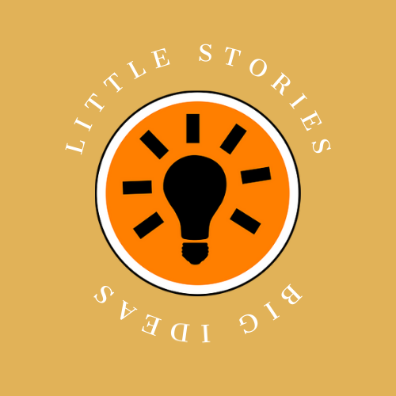
Theme: Body

Term 3’s theme “BODY” drew the greatest response in the two-year history of Little Stories, Big ideas with 385 entries pouring into our inbox from secondary school students across every state and territory, including home schoolers, and The School of the Air!

Entrants certainly had some big ideas when it came to interpretation of the theme. From the literal to the abstract, the inventive and the emotive, we were captivated by the power and the passion of their words. Not only was this round a reminder of the scope of talent Australia’s young writers wield, it served as a potent demonstration of micro fiction’s “less is more” power. Many of the 100-word stories received certainly punched above their weight!

From body love to body shame, body horror and beyond, students didn’t just skate up to the line of existential exploration, they took a flying leap across it with glorious results. Others wrote creative responses touching on everything from #MeToo to machines, oceans to emotions, art to AI, and sexuality to sustainability.

While the level of talent was a joy to read (and we read and respect each and every entry), it also makes judging a (happy) challenge! After much rumination and reflection, our winners and honourable mentions have been chosen. You’ll find their names and the entries of our winners and placegetters below. We hope you’ll enjoy reading their work as much as we did.

The theme for Term 4 FEAR has now opened for entries. You can catch our recorded Zoom conversation discussing the various ways students can interpret the theme along with some answers to commonly asked questions.
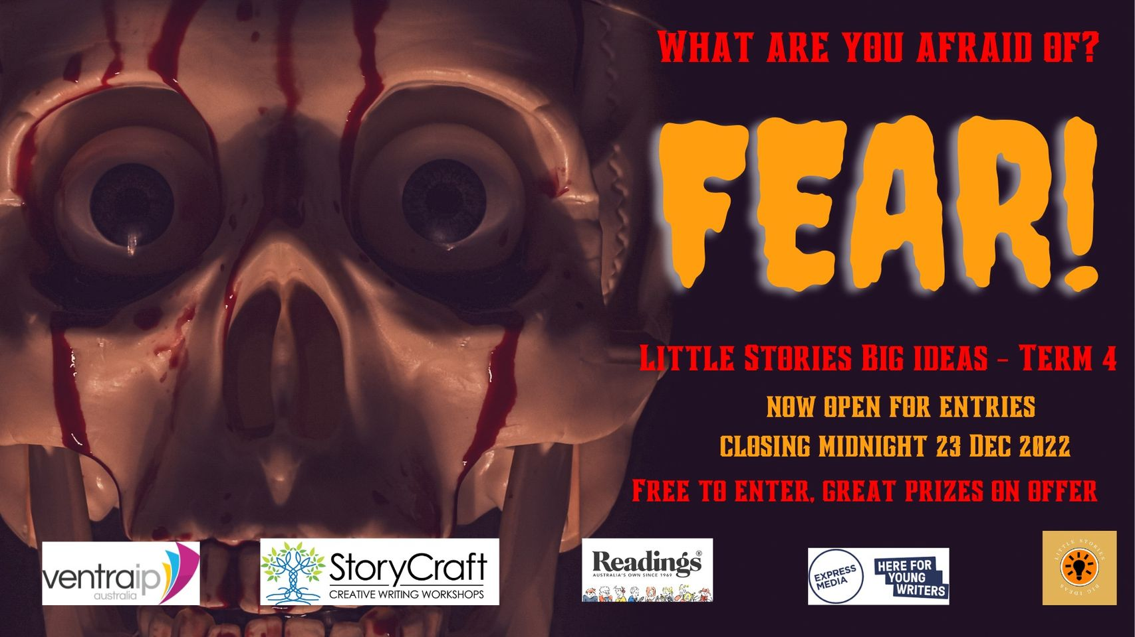
Please spread the word to your students, membership base, children, social networks, and anyone you think would be interested in submitting their work for the chance to win terrific prizes while flexing their creative muscle. We’d love to read their entries!

Thanks for your ongoing support,

Joe and Rebecca

Year 10 - 12 Winners

First Place
Body by Vidushi Trivedi, Our Lady of Mercy Paramatta, NSW

The universe collides
Tethers of explosive hue
Scintillating strands of cosmic hair
From which my body came
Hail the planets!
Luminescence in which mine eyes construct
Mercury running through my veins
Venus spiralling down my divine tresses
Earth in my core, mars under my feet
Jupiter, Saturn, Uranus, Neptune
Run up spine, middle, bosom, temple
Born to my brain, waking the presence of my body
Oh this enchanted form
Chakric charges intermingling
Swirls of planetary fibre
In which this form enacts its steps
Swimming, sinking
My body drifting in oceans of stars
The universe collided
And then my body born

Second Place
Timeless by Emily Crosby, Kolbe Catholic college, WA

fingertips
draw over the bed
tracing the cotton memory
of your hospital pyjamas
seeking
the drum of your heart a rhythm matching the tempo of your thoughts.

in a homesick blur of nostalgia
the empty space
is shaped like you
glowing with the ghost of my favourite colours
your veins
rushing alive with blues and purples
your giggles
sparkling the silence like cherry soda
your neck
glittering with the bubblegum scent of your perfume

i reach to twirl
your strawberry tornado of hair
instead my nails click against
the picture frame on my nightstand
your smile deathless behind the glass.

Third Place
Expired By Syazwani Saifudin, Hoppers Crossing Secondary College, VIC

I pull out my eyeballs, cup them in both palms
soak them in an ice bath, pop them back in
peel off my skin like topsoil, let a new layer of life grow
extract every bone, cement the cracks with fresh milk
dislocate my shoulders and remove all the tons
before returning them weightless
tie my hair to tree branches to let it soar in the wind
absorb that lightness so that when I reattach it
strand by strand, it always keeps me afloat
strip off the soles of my feet, sand out the callouses
add a new soul

Honourable Mention:
- 37° by Shaun Ly, Sydney Technical High School, NSW
- Ocean Town by Sophie Roland, Rosebay Secondary College, NSW
- The Whispering Ink by Rheanna Galea, Gosford High School, NSW
- Poetry in Motion by Noah Green, Gosford High School, NSW
- Body Art by Jessie Walton, North Lake Senior Campus, WA
- Five Faces by Caro Fosser, Figtree High School, NSW
- The Golden Child by Zoe Peck, Westbourne College, NSW
- Breath of Midnight by Alexander Johnson, Mansfield State High School
- Le Corps by Amelia Tu, Shalom College, QLD
- Our Bodies by Nina Tyson, Gosford High School, NSW
- Fashioning Frankenstein’s Monster by Athena Jiang, Danebank Anglican School for Girls, NSW

Year 7 – 9 Winners

First Place
Alter Me Up by Norah Salameh, Beverley Hills Girls High School, NSW

Alter Me Up,
the way You like.
sew the threads
to connect my skin,
and weave my hair
into my scalp.
bind my waist
until it's so thin,
too thin for me
to breathe.
then, dress me up
like a doll
in pretty pink.
i'm a playhouse,
You're the kid.
dance inside of me,
and run wild.
until You're tired,
and i'm beat down.
then once again,
Alter Me Up,
because You're the Man,
and i'm just
A Mannequin.

Second Place
Fishing Trip by Sophie Nham, Perth Modern School, WA
Sunday morning
Trample down hidden path
Push aside twisting tendrils
Until you reach it, glittering in morning sun
Bait the rod, then cast
Water ripples as it sinks into the murky abyss
Then wait…
and wait…
Watch leaves drift across the surface
Listen to birdcalls from above
Then, a tug
Sharp, like needle prick
Wind back, then pull
Stumble backwards as you drag it up onto the shore
Stifle a scream
A girl
Skin white as porcelain
Eyes a muddy brown
Hair matted, yet still stringy yellow
Lips a bruised blue
A blue nightdress, torn
Decayed, yet unmistakable
Margot?

Third Place
The Greed of The Body by Ryan Allen, Randwick Boy’s High School, NSW
The rangers of Rengrove Reserve were in the boardroom with the corporate body of Alexander Industries, arguing against them bulldozing Rengrove Reserve.
Ranger Jeremy began by saying, “You plan to slaughter inordinate populations of wildlife…”
The rangers exhibited their evidence.
The honourable Miss Penelope came to deliver the verdict. She stared down the rangers with disdain. “The body will continue our plans.” She said effervescently.
Jeremy thought, how can she be titled honourable and show no honour? How can they be titled a ‘body’ yet have no heart or soul?
“I guess we’ll see you in court!” He said disgustedly

Honourable Mention:

- Not My Body, No More by Alna George, Yeronga State High School, QLD
- Dame by Olivia Campbell, Presbyterian Ladies’ College, VIC
- Human by Zoe Morris, Melbourne Girls’ School, VIC
- Torture by Harshitha Jonnalagadda, Mt Waverley Secondary College, VIC
- Stars and Blood by Aurora Delvescovo, ET Secondary College, NSW
- Staring by Zi Ao Zhou, North Sydney Girls’ High School, NSW
- Arts and Crafts by Mikah Williamson, Bunbury Senior High School, WA
- The Mortuary Assistant by Maddie Flentje, Thornbury High School, VIC
- Soon to be Star by Ava Bond, Saint Mary Mackillop College, ACT
- Methamphetamines by Tara Jayaguhan, Gosford High School, NSW
- Body Paragraphs by Ellen Wei, Taroona High School, TAS

