Judge's Report - Term 2, 2022
Theme: Ghost

Before we kick off the commendations for Term 2’s competition, we’d like to extend our heartfelt thanks to our newest sponsor Ventra IP and Domain Hosting, who have donated an amazing package to our ever-growing prize pool. Welcome to Little Stories, Big Ideas, Ventra IP, we greatly appreciate your generous support of Australia’s talented young writers!

Speaking of talent, as we’ve come to expect from Generation Next, there was no short supply in Term 2! The theme of GHOST summoned a supernatural response, both in creativity and competence, with a record 260 entries haunting our inbox from every state and territory.

From ectoplasm to existentialism and cemeteries to cyber space, students made the most of their 100 words, delivering micro stories that rattled their chains in our hearts and minds long after reading. While some entrants chose to forge their words around the more traditional interpretation of the theme: gothic tropes, haunted houses, paranormal entities, the afterlife…and the delicious thrill of a good scare, others leant in to more abstract forms, exploring the metaphorical ghosts that haunt our contemporary age.

As always, we applaud and appreciate the time and effort of all our entrants. We respect their words and creative expression, and celebrate their imaginative and impactful responses. Judging such diverse works makes for a happy challenge!

Without further a-boo (see what we did there?) the following winners, place getters, and honourably mentioned students represent the scope of talent the young writers of Australia currently exhibit.

There are no shadowy corners for these upcoming literary stars…

The theme for Term 3 BODY has now opened for entries. A timely and topical word, we feel, and one we know Australia’s talented young writers will each apply their unique lens to.
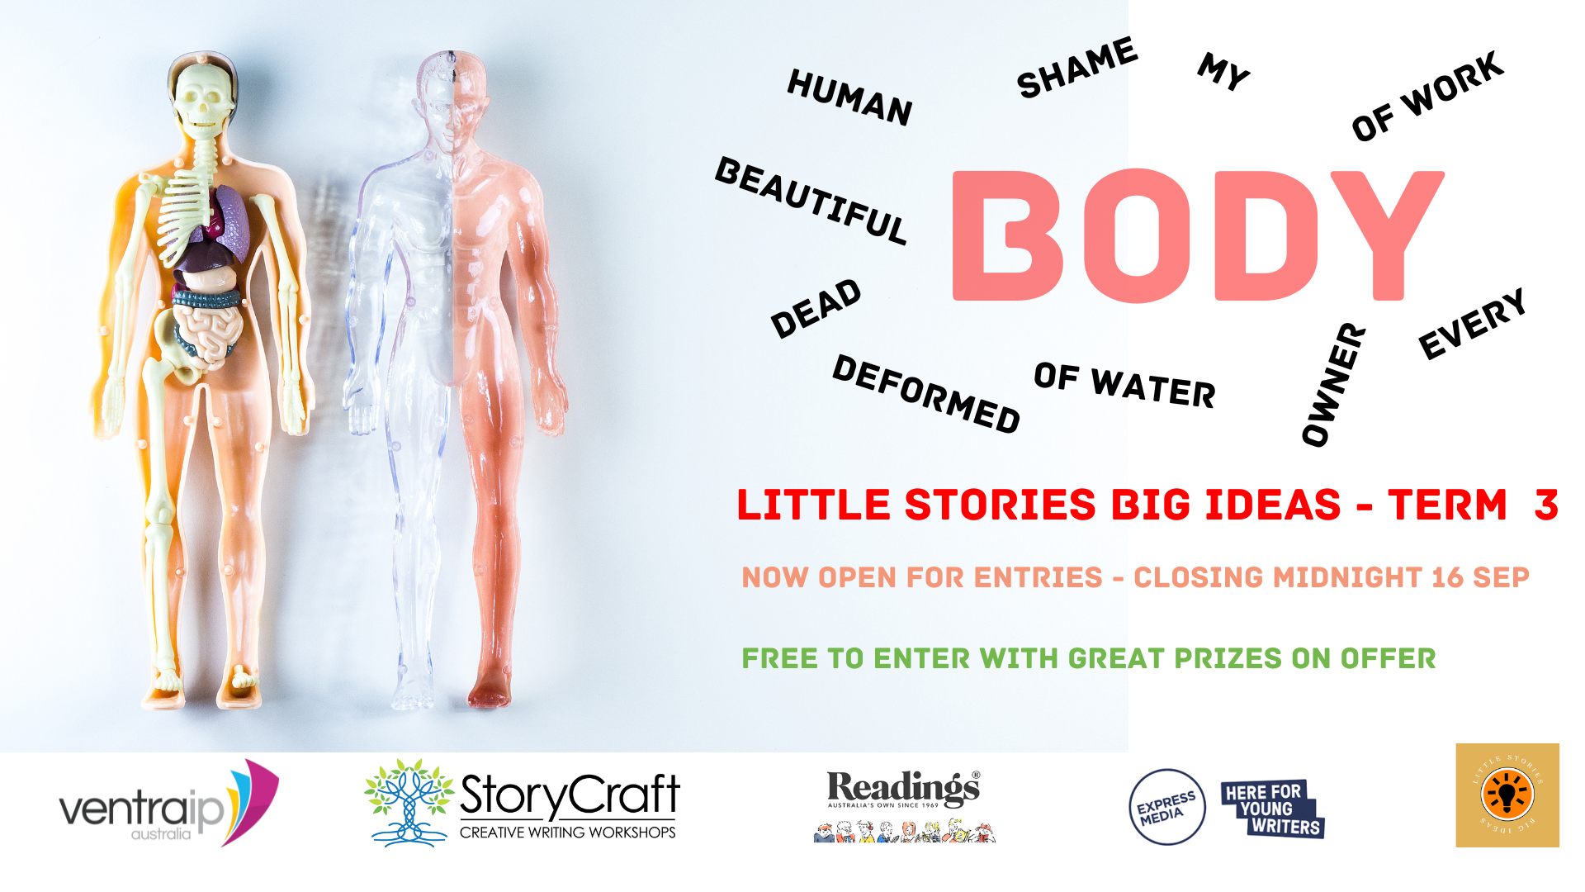
Please spread the word to your students, membership base, children, social networks, and anyone you think would be interested in submitting their work for the chance to win terrific prizes while flexing their creative muscle. We’d love to read their entries!

Thanks for your ongoing support,

Joe and Rebecca

Year 10 -12 Winners

First Place
The Dancer by Maxine Fan of Lauriston Girls’ School, VIC

Ivory light
Floods a swirling silhouette
Sparkling eyes
Limbs outstretched
Sweeping like a swallow
The swell of the orchestra becomes
A vessel
A softly rocking boat that never stills
Cradled by restless waves-
lapping at her steps
She dances on
Under moonlit shores
The music dips and
She slows
Delicate leaps turn into
A trembling stillness
Her sigh
Conceals a mournfulness
A gentle subdued yearning
Quivering fingers brush the dusted frame
The glass is cracked
In the corner
Just slightly
The photo has faded
Her dance is art
Her art is her life
A rueful smile
It was her life.

Second Place
You’re My Friend, Right? By Haobo Zhang of The Geelong College, VIC

1/02
hi
hi
why are you leaving me on seen?
hello?
did I do something wrong
please say something

3/02
stop leaving me on seen
why aren’t you responding
we’re friends right?
please
you’re the only person i can talk to
please

4/02
what’s going on!
why aren’t you talking to me!
please
i was alone at snack and lunch again
why are you ignoring me
i just want you to talk to me again
i’m really sorry if i did something you didn’t like

11/02
i’m sorry
i’m sorry
i’m sorry

Third Place
How to be a Ghost by Belle Harvie of Moss Vale High School, NSW

First, be dead inside.
Second, hate everything.
Nothing in life gives you joy.
Third, enjoy people’s miseries.
Your pleasure is their pain.
Fourth, Plan your tombstone.
Upset the dead spirits.
Fifth, Escape reality.
Go missing.
Sixth, remind someone of their past.
Scare those who care about you.
It doesn’t matter how; just do it.
Sixth, when someone hurts you, DO NOT REACT.
You’re a ghost; you feel no pain.
Rarely, let emotional pain hurt you.
RARELY.
Seventh, wear a white sheet sometimes.
Get used to your future body.
Repeat. For as long as you like.
In whatever order.

Honourable Mention:
- A Banquet Spirit by Eileen Carmelita of St Thomas More College, QLD
- Just One Short by Nibesh Khatri of Perth Modern School, WA
- World’s Too Fast for Ghosts by Joshua Pinga of St Luke’s Catholic College, NSW
- Butterfly Abyss by Amelia Tu of Shalom College, QLD
- Poltergeist Problems by Krissy Vavlas of Strathmore Secondary College, VIC
- New by Maddi Lipscomb of Mansfield State High School, QLD

Year 7 – 9 Winners

First Place (Judge’s Note: Haiku – Demonstration of how the rules of form combined with the power of a few well-chosen words can be presented with stunning impact)
Loss by Nga Nguyen of Mount Gambier High School, SA

Pale skin, blue lips lied
My mother laid in the snow
She won't hold my hands

Second Place
Falling: Either in Love or to Death by Natasha Hague of All Saints College, Maitland
Why is it that love is always described as something you fall into?
A shock,
A surprise,
A taste of freedom when in reality it is only the few short seconds before you hit the ground.
I too am currently falling, however not in love,
Instead flying downwards,
Flying and falling,
Falling freely towards a beckoning sea.
Wind running after me,
A crash.
A splash.
A long-expected collision.
Maybe this is what love is, a freeing type of falling down, a slow succession through life.
When your soul doesn’t fall but floats,
Lighter than a whisper in the wind.

Third Place
Misconceptions by Isabella Chalker of Bunbury Senior High School, WA

Two ghostly figures mounted on the wall, stuck in the make-believe world of a dusty picture frame. Don’t step on the third step of the staircase because you might wake them up and their shadows might move. Make sure you close the door or else a demon will wail through the gap. Make sure you lock the window or a shadow will enter your room. Never just a painting, never just the wind, never just a tree. A house ruled by shadows and the dark. A house ruled by people in a picture frame. A house ruled by misconceptions.

Honourable Mention:

- In Another World by Phillis Chen of St Thomas More College
- Eternal by Todd Frahn of Open Access College, SA
- The Breath of Night by Indiana Palmer, Bunbury Senior High School
- Mirrored by Emily Hague of All Saints' College, Maitland
- Desolate by Miller Read of Bunbury Senior High School, WA
- My Diary, June 2021 by Ava Bond of St Mary Mackillop College, Canberra
- Where the Wild Things Start by Abbey Lim of The MacRobertson’s Girls’ High School
- Your Ghost Still Haunts Me by Lincoln Wheeler of Lumen Christi College, WA
- Misconceptions by Isabella Chalker of Bunbury Senior High School, WA
- The Jerboa Ghost of Wizz Creek by Humus Chandu of MESC

